D08 – Lessons learnt Responsibility statements

Identification data

Group 11
Level A

https://trello.com/b/bGfzXuud/deliverable-8 URL of your project management system

https://github.com/AlfonsoSoldado/rendezvous-group11.git
URL of your project repository

Sevilla, 27th february 2018

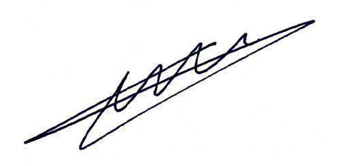
_____________________________________ Cienfuegos Izquierdo, Adam

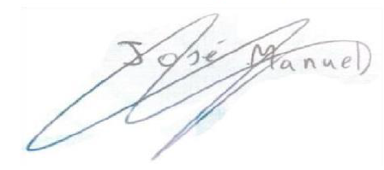
_____________________________________ Rojas Granado, José Manuel

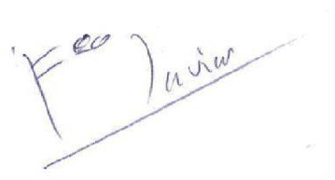
_____________________________________ Fernández Montero, Francisco Javier

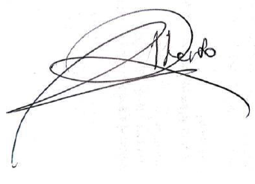
_____________________________________
Ríos Zea, Alberto

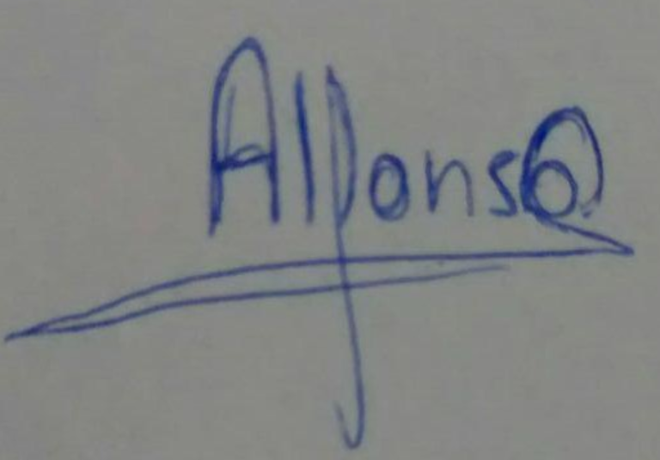  _____________________________________  Soldado Caro, Alfonso |  | 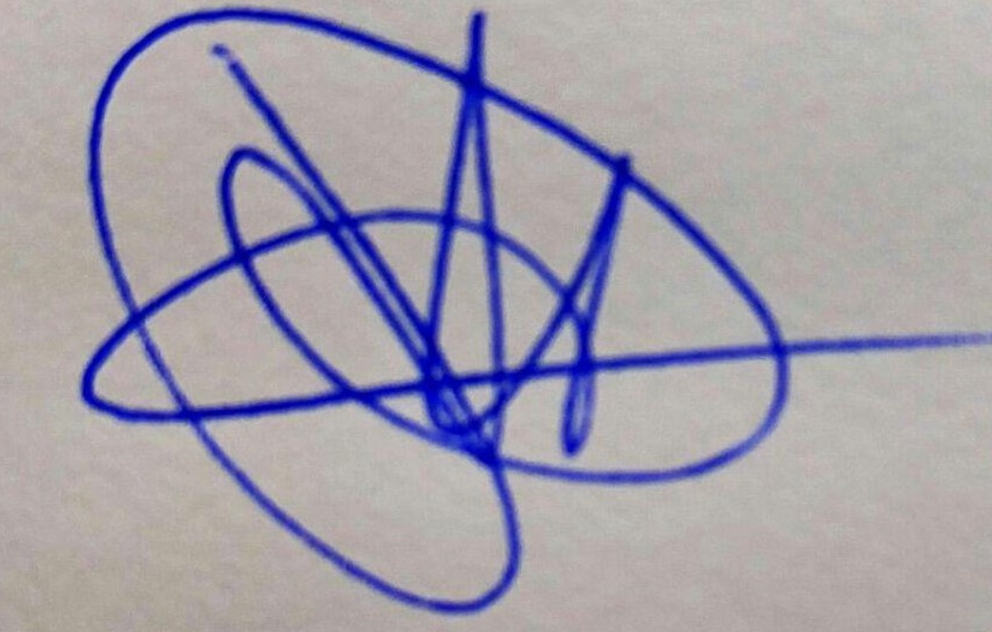  _____________________________________  Rodríguez López, Daniel
Responsibility statements
 | [X] I am an author of this deliverable. I have not cheated in any way.
 | [X]I have collaborated with my partners on producing this deliverable; in other words, neither have
I ridden their coattails nor gobbled them up.
 | [X] I have learnt from working on this deliverable, so that I can pass my control checks.
 | [X] I have organised this deliverable according to the guidelines that are available in document “On
your deliverables.pdf”, which is available at the USE’s e-learning platform.
 | [X] I understand that my deliverable will be considered failed if I fail to meet any of its require-
ments, if I fail to submit it by the deadline, or if I do not deliver a filled copy of this form.
 | [X]I understand that failing this deliverable might amount to failing the subject.
 | [X] I understand that I must have a contingency plan and that submitting my deliverable very close
to the deadline is likely to result in disaster.

